Session 1 - Getting the data in

Jono Tuke

21 May 2015

In this session we will show you a few ways to get data in from text files and excel files.

# Getting the data

First we need to download the data. The data is found in here.xls

y <- rnorm(100)  
head(y)

## [1] 0.5956211 -0.4055840 1.1012357 -0.6395450 -1.8988120 0.8226599

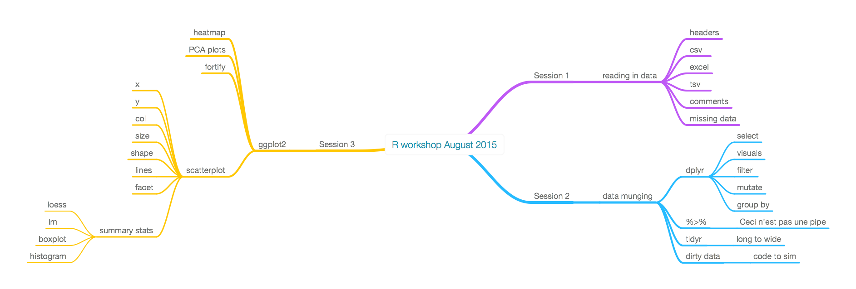

hist(y)

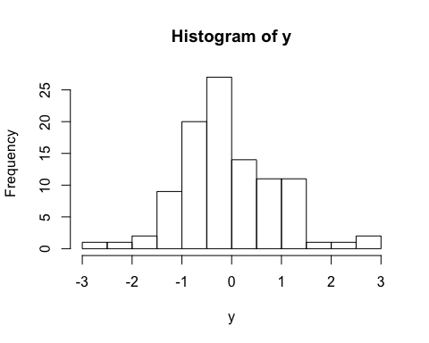

$y=x^{2}$

# Using menu to load data

# Using commands to load data

# Dealing with headers

# Dealing with comments

# Dealing with missing values